The North Carolina State Crime Laboratory is switching to a new method for scheduling evidence submission and return appointments. Instead of calling the Laboratory to book an appointment, we will be utilizing an online booking program where you can see available dates/times, then choose the opening that works best for you. This means you can schedule or modify your own appointments on demand, 24/7, providing you with immediate confirmation and helping free up our technicians.

In order to schedule appointments, you must have FA Web access. Once you have logged into FA Web, you will see a calendar labeled Raleigh Lab Appointments at the top of the homepage.

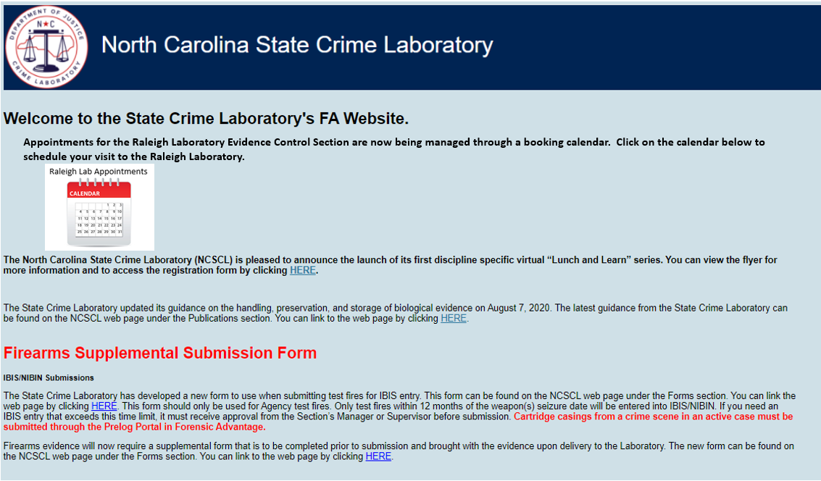

Clicking on this calendar will take you to our Raleigh Bookings page:

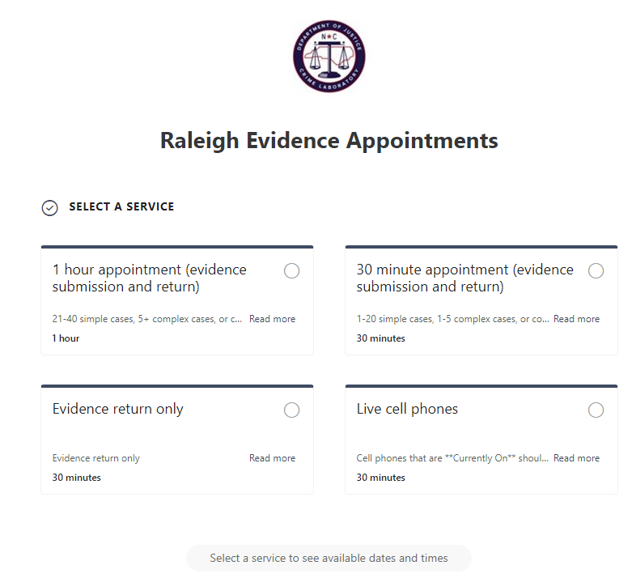

From here, select the appointment you need based on the type and/or amount of evidence that you will be submitting. Appointments are available for evidence submission and return in 30-minute and 1-hour blocks, as well as appointments for evidence return only. We also offer a standalone appointment for live cell phones that must be submitted to Raleigh as soon as possible.

Once you have selected the appropriate service, the calendar and available times will be displayed.

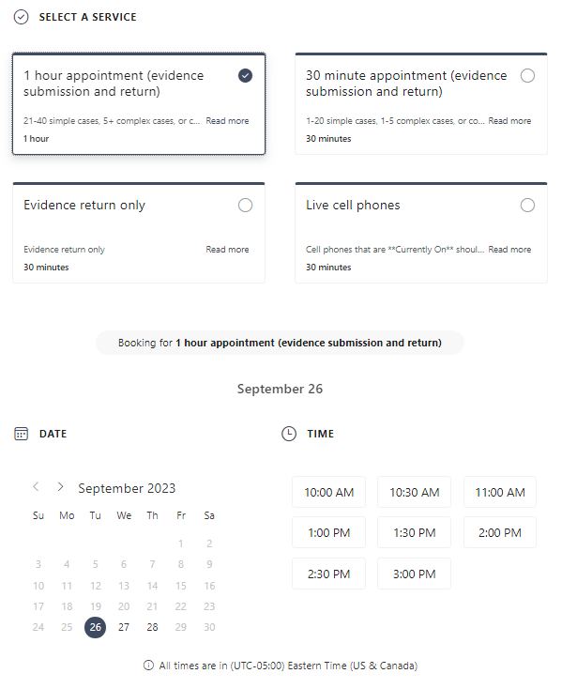

From the calendar section, choose an available date and time, then enter your details. Fill out your **Agency name** in the first block, followed by the Submitting officer’s email, name and phone number. Once completed, click **Book** to confirm.

Please note, appointments must be made at least 24 hours in advance (with the exception of live cell phones). For emergency situations, please call Evidence Control at (919) 582-8840 to inquire about same-day appointment availability.

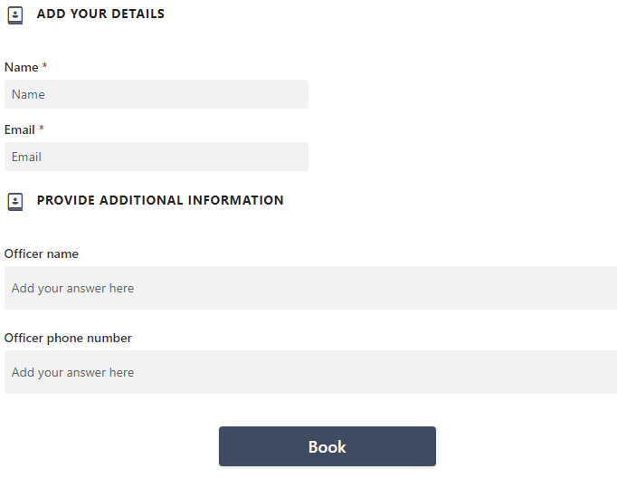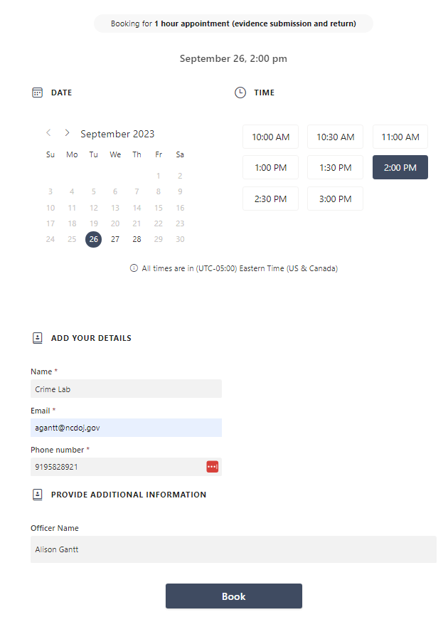

After clicking Book, the confirmation screen shows the appointment date, time and service that you selected. From this screen, you can:

* Update or modify your appointment by clicking **Reschedule**,
* Cancel the appointment by clicking **Cancel booking**, or
* Create additional appointments by clicking on **New booking**.

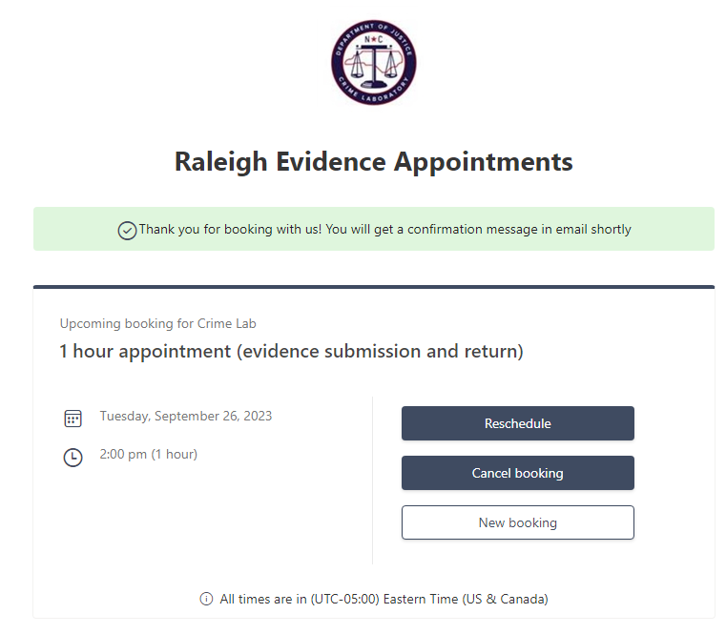

Unfortunately, there is no way to set recurring appointments at this time. If you would like to schedule multiple appointments, please click New Booking and repeat the process for another date/time.

For each booking that you create, you will receive a confirmation email with your appointment information, as well as a link to **Reschedule**. This linkwill take you back to your appointment confirmation where you can reschedule or cancel your appointment.

You will also receive a reminder email the day before your next appointment. If you are unable to make your appointment, we ask that you cancel it as soon as possible in order to allow another agency to book that time slot.

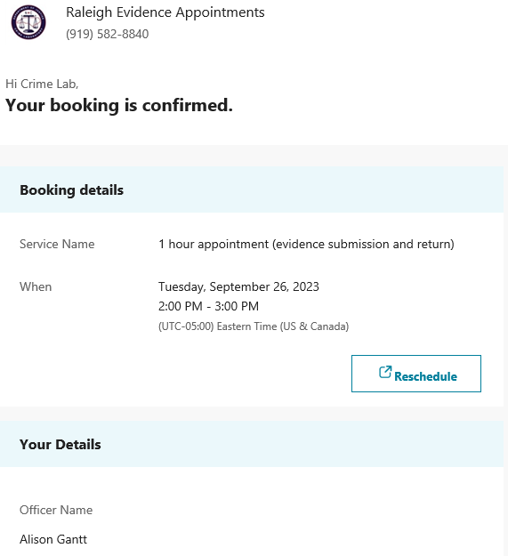Confirmation email: Reminder email:

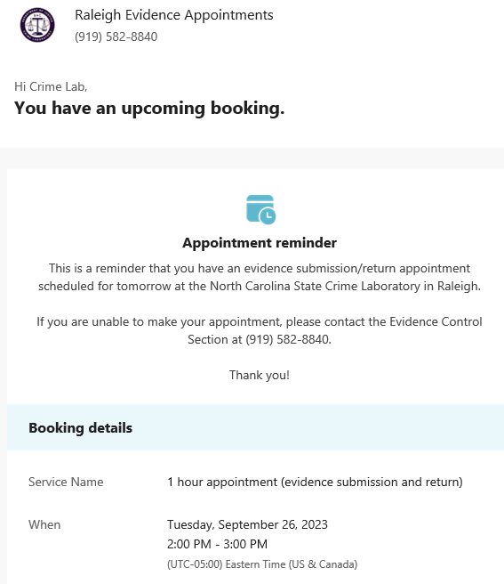

As always, if you need to rush evidence to the Laboratory, please give us a call and we will work with you to get you seen as soon as possible.

If you have any questions about the new booking process, please contact:

* Raleigh Evidence Control – (919) 582-8840
* Tim Baize – (919) 582-8865
* Alison Gantt – (919) 582-8921